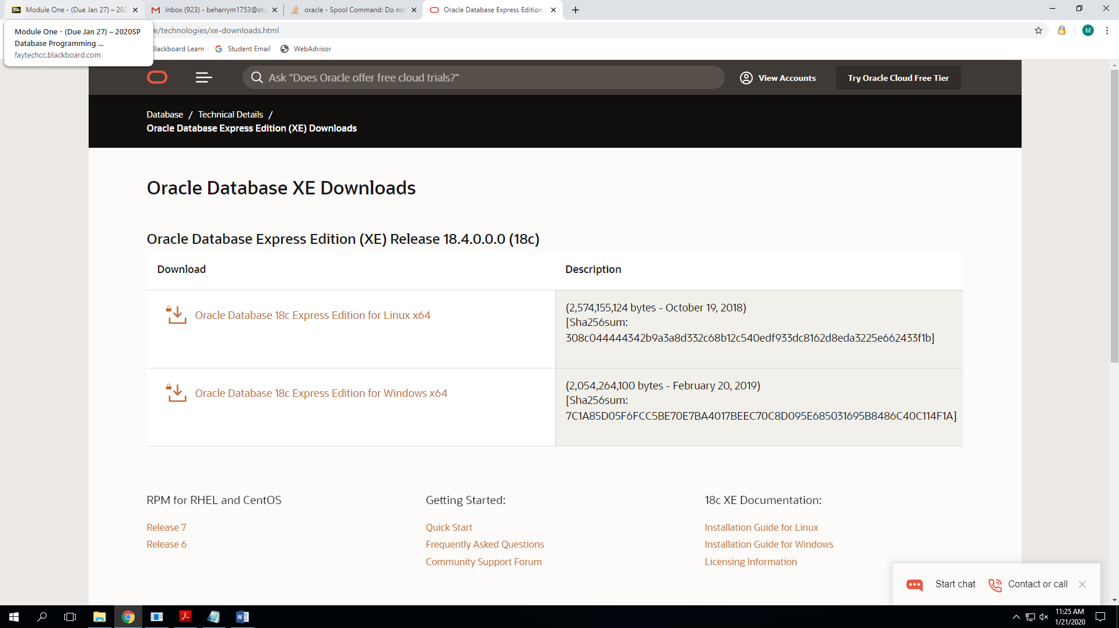

**SQL IS NOT CASE SENSITIVE EXCEPT THE PASSWORD**

SPOOL {*Path*}[*Filename*]

SPOOL F:\2020SP\DBA-120-0001\J21_BeharryMathias

Defaults to .lst file, use .SQL to turn into sql file, use .TXT to turn into text file.

Spool should be the same name as the user.

Use SHOW SPOOL command whenever you can.

Use SPOOL OFF when you are done.

Use C## when creating a user and add ; to the end of the command line.

CREATE USER J21_BeharryMathias **WRONG**

CREATE USER J21_BeharryMathias; **WRONG**

CREATE USER C##J21_BeharryMathias IDENTIFIED BY password; **CORRECT**

Use SHOW USER whenever you can.

GRANT DBA TO C##J21_BeharryMathias;

Grants certain permissions to users.